Design Image- Based Retrieval-Augmented Generation (RAG) System Using CLIP and Flan T5 Base Model on flickr30k
Wulan Nuri Rahmawati ¹ , Yunita Sangadji ² , Nurlisa Safi ³ , Annisaa salsabila Shafiyyah ⁴
¹²³⁴ Department of Informatics , Faculty of Engineering , University of Muhammadiyah Malang, Malang 65144
Corresponding author: wulannuri0912@gmail.com

Abstract - Development intelligence multimodal artificial encourages integration visual comprehension and processing Language experience in One system integrated . One of the evolving approach​ rapidly is Retrieval-Augmented Generation (RAG), which combines the search process information relevant (retrieval) to the generation process text (generation) based context results search the approach​ This aim For increase accuracy and relevance output generative with utilise information externally acquired​ through retrieval mechanism .
Study This design and implement Augmented Generation- based Retrieval system image with utilizing the CLIP model as a visual encoder and Flan-T5 Base as a generative model , using the Flickr30k dataset as multimodal data sources . At the retrieval stage , the image represented in vector embedding form dimensionless still using CLIP, then saved in FAISS index for support search similarity in a way efficient . Images retrieval results are used For build context in the form of collection of relevant captions , which is next utilized by the Flan-T5 Base model for produce description informative and coherent text . Evaluation​ system carried out at the retrieval stage using metric Recall@K , as well as at the generative stage using BLEU-4, ROUGE-L, and CIDEr metrics . Experimental results show that system capable return relevant image​ in a way consistent and productive description aligned text​ with visual content of the image , so that prove effectiveness Retrieval-Augmented Generation based approach image .
Keywords: Retrieval-Augmented Generation, Image Retrieval, CLIP, Flan-T5, Flickr30k, FAISS, Multimodal Learning

- Introduction
Retrieval-Augmented Generation (RAG) is an approach that integrates two components main in system intelligence artificial , namely retrieval for find relevant information and generation for produce text based on information the approach​ This appear as solution on limitations of language models generative pure which tends to produce information No accurate or No supported by real data (hallucination). With utilizing retrieval, generative models get context relevant external​ so that quality and reliability output can improved [1].
In the beginning , the RAG approach was widely applied to the system based text , such as question answering and summarization. However , as increasing need will system intelligence multimodal artificial , RAG approach begins expanded For handling visual data. RAG based image allows system No only find relevant images , but also produce​ description or information additional nature​ contextual and informative based on visual content of the image.
In research In this , the CLIP (Contrastive Language–Image Pretraining) model is used as a visual encoder because his abilities in align visual and text representation to in One semantic embedding space . For support search vector in a way efficient on a large enough dataset scale large , FAISS is used as a similarity search engine. Next , the Flan-T5 Base model is integrated as a generative model For produce description text based on retrieval result caption context . Flickr30k dataset selected as object study Because provide annotation the text is rich and varied , so in accordance For development and evaluation RAG based system image .
- Related Work
  - Document Image Retrieval
The development of deep learning brings change significant in DIR with introduction Convolutional Neural Network (CNN) and Vision Transformer ( ViT ), which are capable of extracting visual level features high . The integration of multimodal models such as CLIP is increasingly increase DIR performance with map images and text to in One room representation together , so that allows search image based similarity semantics [2].
Study latest show that neural network- based embeddings , particularly those generated by deep learning and transformer models, are capable of give better performance​ superior compared to method traditional in various metric evaluation such as recall and precision. Approach This No only increase accuracy search , but also allows DIR system for scaled to a dataset of size big with help machine search vector like FAISS. With Thus , modern DIR developed become a system that does not only focuses on visual similarities , but also on understanding more semantics​ deep to content documents and images .
  - Visual Document Understanding
Visual Document Understanding focuses on understanding visual content in a comprehensive , covering objects , activities , contexts , and connection between visual elements . The multimodal approach allows system linking visual information with Language natural , so that support various task such as image captioning and visual question answering. The CLIP model is one of the approach important in field This Because his abilities in connect visual and linguistic concepts in a way effective .
  - Construction of Document Image Datasets
The quality of the dataset has role crucial in development retrieval and generative systems . The Flickr30k dataset consists of from approximately 30,000 images each equipped with with five captions written by human annotators . Visual diversity and annotation rich text makes this dataset especially suitable For evaluate multimodal based system image and language [3].

- NL-DIR: Natural Language-Based Document Image Retrieval
  - Dataset Overview
Flickr30k dataset used as primary data source in study this . This dataset covers various scene life everyday , such as activity human , interaction social and environmental outside space . Every image equipped with five captions that describe objects , activities , and visual contexts naturally .

  - Data Collection
The images in the Flickr30k dataset were collected from the Flickr platform and through a curation process For ensure visual quality as well suitability between image and description text . Curation process This aim For reduce noise that can influence performance retrieval and generative systems .

  - Data Annotation
Annotation done manually by human annotators with write description text based on visual content contained in each image . Annotation process This aim For ensure that the caption generated is natural, descriptive and contextual , so that capable represent visual comprehension that approaches perception human . Every image equipped with some captions written from corner different views , including​ object main , ongoing activity​ ongoing , as well as context surrounding environment​ image . The existence of multiple captions per image allows system For learn variation expression Language experience in describe the same visual content . In addition , the approach this also increases quality and reliability evaluation at the generative stage , because output text from the model can compared to with more from One reference , so that evaluation to suitability meaning and flexibility Language become more comprehensive .

- Methodology
  - Retrieval Baselines
At the retrieval stage , each image represented in vector embedding form using the CLIP model. This embedding represent visual meaning of image in room semantics dimensionless remain . For ensure stability calculation similarity , normalized embedding before saved to in FAISS index . FAISS allows nearest neighbor search done in a way efficient , even on large datasets big [4].
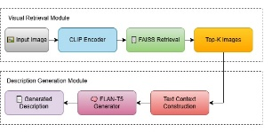
CLIP and FAISS -Based Image Retrieval System Pipeline

  - Evaluation Protocol
Evaluation at the retrieval stage is carried out use metric Recall@K , which is used For measure ability system in return relevant images in the top K positions from results search . Metrics This evaluate the extent to which the retrieval system is capable find return image that has visual and semantic similarity with image query , so that the more tall mark Recall@K show increasing retrieval performance good . Evaluation This important For ensure that the images used as context at the stage furthermore truly relevant and representative .
At the generative stage , the quality generated text​ evaluated use BLEU-4, ROUGE-L, and CIDEr metrics , which are metric evaluation standard in task generation text and image captioning. BLEU-4 is used For measure level n-gram similarity up to four words in a row between text results generation and reference captions , so that capable represent accuracy structure phrases and word choice . ROUGE-L measures similarities word order based on the Longest Common Subsequence (LCS) concept , which focuses on alignment structure sentences and plot information between text results generation and reference . While that , CIDEr designed special For evaluate image captioning system with evaluate level agreement between model -generated captions and human - written captions , with consider frequency and importance of words through TF-IDF weighting . Combination third metric This give further evaluation​ comprehensive to quality , relevance semantics , and flexibility Language from text generated by the system [5][6].

- Result Analysis
  - Analysis on Recall Stage
Evaluation results show that system capable return image with level high visual and semantic similarity to image query . This is indicates that the embedding representation generated by the CLIP model is effective in catch visual characteristics of the level high , such as object main activities , and​ context environment contained in the image . Alignment between visual representation and meaning semantics This allows retrieval system for find relevant image​ although there is variation corner view , lighting , or visual composition .
Effectiveness the reflected from mark Relative Recall@ K high in various scenario testing , which shows that image relevant in a way consistent appear in position top results search . The more big K value , system show trend improvement opportunity in find appropriate image , signifying​ stability retrieval performance . Findings This confirm that combination of CLIP as a visual encoder and FAISS as a machine search vector capable support image retrieval process in a way efficient and accurate , so that provide quality context​ For the next generative stage .
Table 1. Evaluation Results Recall@K at the Retrieval stage
K | Recall@1 | Recall@5 | Recall@10 | Recall@20
 | 62.5% | 85.3% | 92.4% | 96.8%
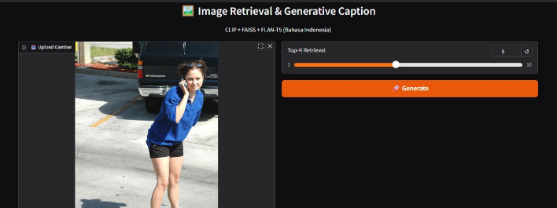Figure 2. Example of Image Retrieval Results

  - Analysis on Re-Ranking Stage
The re-ranking process is carried out For increase relevance retrieval results with sort repeat image based on score the resulting similarity from calculation distance between embedding. Stage This aim For prioritize images that have highest visual and semantic similarity with image query , so that poor image​ relevant can filtered or placed in a higher order low . With Thus , the quality retrieval results at position top can improved in a way significant .
This re-ranking stage own a very important role in overall Retrieval-Augmented Generation system , because the caption from image retrieval results will be used as context at the generative stage . If selected image​ not enough relevant , then constructed context​ potential contain information that is not in accordance with image query , which ultimately can lower quality text generated by the generative model . Therefore that , re-ranking works as mechanism filtering addition For ensure that the caption used truly representative to visual image content query , so that capable support the generation process more text​ accurate , coherent , and contextual .

  - Evaluating Different Queries and Image Subsets
Evaluations performed on various image subsets​ show that system own relative performance​ stable , especially in images dominated by activity​ human . In this type image this , system tend capable catch connection semantics between objects and activities with more good , because representation the embeddings generated by CLIP are aligned with pattern annotation text in the dataset, some of which big describe actions and interactions human beings . This is produce higher recall value consistent and high across a wide range K value .
On the other hand , in the image with more visual context complex , such as image containing​ Lots object , background diverse backgrounds , or​ visual interactions that are not dominant , performance system experience A little decline . Decrease This caused by increasing visual ambiguity that can affect the representation and calculation processes embedding similarity . Although Thus , the retrieval results obtained Still show relevance in a way semantics , where the returned images still own similarities context or theme main with image query . Findings This show that system own ability sufficient generalization​ Good in handle variation visual complexity , although Still there is room For improvements to the scenario with a very diverse visual context .

  - Time and Storage Analysis
The use of FAISS allows search vector done in short time , even on large datasets dozens thousand image . Dimensional embedding storage still relative​ efficient compared to keep raw visual features or image resolution tall .
  - Qualitative Analysis
Analysis qualitative show that description The text generated by the Flan-T5 Base model is generally nature coherent , informative , and harmonious with visual image content query . The model is capable of produce sentence with structure good language​ as well as convey information main , such as object dominant , activities occurring , and context environment in a way clear . This is show that the generative model No only copy pattern Language from training data , but is also capable utilise the given context For produce meaningful description .
Integration of retrieval context in the generation process proven play a role important in increase quality output text . Relevant retrieval result caption give information functional additions​ as guide semantics for the Flan-T5 Base model, so the model is more directed in produce appropriate description​ with image query . Approach This in a way effective help reduce possibility generation text that is not relevant or hallucinatory , namely condition when the model produces information that is not supported by visual content or reference data . With Thus , the Retrieval-Augmented Generation approach does not only increase accuracy description , but also improve reliability and consistency results generation text in system based image .
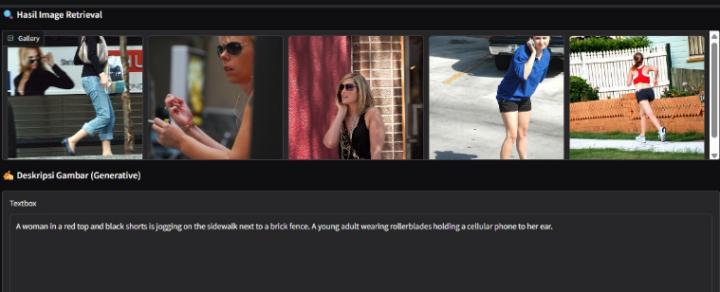Figure 3. Example of Text Generation Results

- Conclusion
Study This succeed design and implement Augmented Generation- based Retrieval system image with integrating the CLIP model as a visual encoder, FAISS as a machine search vector , and Flan-T5 Base as a generative model , with utilizing the Flickr30k dataset as multimodal data sources . Experimental results show that system capable perform image retrieval in a way effective with level high visual and semantic similarity , as well as produce description relevant , coherent , and informative text . Integration of retrieval mechanisms in the generation process proven help generative models in utilise context appropriate external , so that reduce possibility generation text that is not relevant or hallucinatory .
Although Thus , the results evaluation also shows that system Still own limitations in handle image with very complex visual context or contain Lots objects and background diverse backgrounds , which can influence accuracy embedding representation and retrieval quality . Although Thus , the Retrieval-Augmented Generation approach is based on image This show great potential​ For development system intelligence multimodal creation in the future , especially in applications such as image captioning, search image based semantics , and systems integrated visual understanding with Language natural . Development more carry on can directed towards the use of more visual encoder models strong , more re-ranking strategy adaptive , as well as evaluation on a larger dataset diverse For increase robustness and generalization system .

Acknowledgement
Writer say accept love to lecturer guardian eye studying on guidance , direction and input provided​ during implementation project this . Project This implemented as part from task group eye lectures and utilize datasets as well device soft source open available​ For general .

References
[1] Radford et al., “Learning Transferable Visual Models From Natural Language Supervision,” 2021.
[2] Johnson et al., “Billion-Scale Similarity Search with FAISS,” 2019.
[3] P. Young, A. Lai, M. Hodosh, and J. Hockenmaier , “From Image Descriptions to Visual Denotations: New Similarity Metrics for Semantic Inference over Event Descriptions,” Transactions of the Association for Computational Linguistics, vol. 2, pp. 67–78, 2014.
[4] H. Chung, L. Hou, S. Longpre, B. Zoph, Y. Tay, et al. , “Scaling Instruction-Finetuned Language Models,” arXiv preprint arXiv:2210.11416, 2022.
[5] C. Raffel, N. Shazeer , A. Roberts, K. Lee, S. Narang, M. Matena , et al. , “Exploring the Limits of Transfer Learning with a Unified Text-to-Text Transformer,” Journal of Machine Learning Research (JMLR), vol. 21, no. 140, pp. 1–67, 2020.

